A Gematric Approach to the Mystic Word (2017)
A Short Talk by Em Fr John Williamson CRC, 7°
William Wynn Westcott College, SRIA

For those unfamiliar with the subject, Gematria originated as an Assyro-Babylonian-Greek system of alphanumeric cipher that assigns a numeric value to a word, phrase or sentence in the belief that words, phrases or sentences with identical numerical values bear some relation to each other. It is, of course, only truly legitimate in those languages where each letter of the alphabet is also recognised as a number. The languages mentioned do have that sort of alpha-numeric correspondence as does Hebrew and so it is easy to find other words with the same so-called characteristic number as the source word and many such correspondences delve deeply into the mystical meaning of that word. The technique was introduced into Jewish Kabbalism which is now probably the commonest form of gematria in use.
English does not have an alphabet doubling as numbers but bible scholars have developed a tentative alpha-numeric relationship for the language which has been used over the last hundred years or so the investigate the so-called ‘Bible Code’. This, however, we are not going to pursue today.
We will instead restrict ourselves to the Hebrew Gematria and that mostly because it is the most studied technique available, rabbis having investigated and dissected their holy book, the Tanakh, over many centuries. The correspondences I sought were from Jewish number/word dictionaries but these do not go beyond individual words – so phrases and sentences are necessarily under-represented. The Hebrew alephbeth has 22 original letters and five final forms for K, M, N, P and Tz. This yields 27 characters which constitutes three rows of 1-9, 10-90 and 100-900.
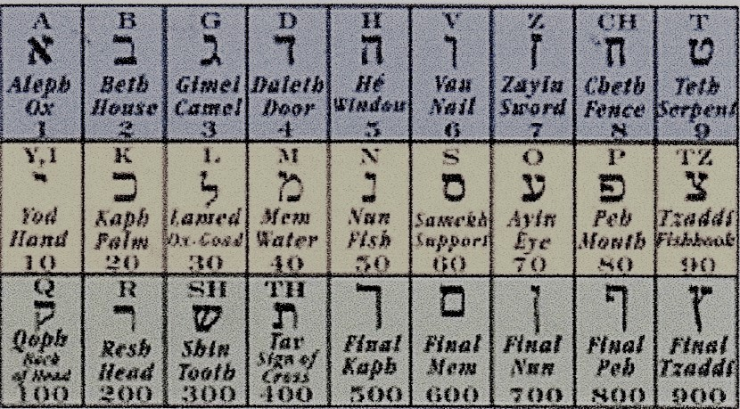
Using this system means we can record numbers up to 999. Writing the letter at double size means you must add 1000 to the base number and then you can count up to 999,000!
It is important to recognise that abbreviations or ancient Hebrew words where the vowels are not written down can be investigated either as they are written or in plenitude, a term that means the full phrase or with the missing vowels. One Mystic Word can be read as INRI or as Iesus Nazarnus, Rex Iudaeorum [Jesus of Nazareth, King of the Jews]. We immediately walk into a problem, for Hebraic Gematria cannot be used on Latin words or phrases with confidence; we must translate that Latin into Hebrew.
There is a fundamental problem even with that as Hebraic words and spellings varied over time. However, the following is fairly common and long-term. In traditional shortened early Israelite form Jesus gives us YShUA (pronounced Yehoshua). This has a gematric characteristic number of 386. The full translation of Pontius Pilate’s provocative sign is YHShOYH NTZRT MLK IHZDM which has a gematric characteristic number of 1771. The Latin abbreviation or acronym INRI translates to YNMI with a characteristic number of 110.
Let us start with Yehoshua and its characteristic number of 386. Correspondences with a value of 386 give us such descriptors as ‘tongues’ (the ability to talk to the whole world) and ‘Jeshua’ (the priest who helped Zerubbabel build the second temple before establishing the theocratic government of Israel, suggesting that Jesus was the forerunner of a new priesthood).
The Law of Colel holds that a characteristic number differing by only ‘1’ can also offer useful information. The colel correspondences of 386 yield ‘Shekinah’ (the presence of God on Earth}, and ‘bread’ (possibly suggesting the Christian Rite of Holy Communion}.
A fairly new approach to characteristic numbers is to examine the correspondences of their factors and, where relevant, the numbers derived from products of factors provided they do not exceed the characteristic number itself. 386 reduces only to 2 X 193, the latter being a prime number which offers the very illuminating property of ‘righteousness’.
It should be noted that the numbers 1-10 are not given to gematric analysis but are analysed according to the Tree of Life glyph of Judaeo-Christian Qabalism. Factors or products of factors of these numbers 1-10 are not considered further here as we are not extending our analysis to the Qabalistic sephiroth in this short introduction to QabalisticGematria.
In plenitude the name Yehoshua has a characteristic number of 391. This yields ‘heaven’, ‘paths’, ‘life’, ‘salvation’, ‘pray’ and ‘feast’, all pretty obvious aspects of Jesus’s significance.
We have to accept that Jesus was spelt in a number of different ways but the only one contemporaneous with Yehoshua was Jeshuah with a characteristic number of 314 (and factors of 134, 162, 81, 72 36, and 18 – factors below 10 being ignored as above). The correspondences of all these numbers yield such insights as ‘The Almighty’, ‘son of the right hand’, ‘throne’, ‘God’, ‘the Book of Lamentations’ and ‘cut away’. Jesus sits at the right hand of God having ascended as the son of God to that position (think of the Nicene Creed) on a heavenly throne after being separated from his disciples who were filled with lamentation after their leader’s death and burial.
All this has shown how Gematria can point to significant descriptors of the source word but as we increase the complexity of the original so does the list of correspondences grow and it is probably too complex a task for a talk of this length to delve much further into the names of Jesus.
Turning to INRI, or rather the Hebrew equivalent which is YNMI with a characteristic number of 110, we can using the same techniques but ignoring the issue of plenitude generate correspondences of ‘Father of Faith’, ‘the right hand’ (an Israelite term for sonship), ‘eminence’, ‘fishes’ (think of the vesica pisces, a Christian symbol of Jesus Christ often seen on the back of motor cars, or the word ΙΧΘΥΣ [Ichthos} which means ‘fishes’ but is also an acronym of (I) Iesous (Χ)Christos (Θ)Theos (Ο) Yios (Σ)Soter, which means Jesus Christ, Son of God and Saviour). Yet more correspondences are ‘to build’, ‘beautiful’, ‘He suffered’, ‘sleep’, ‘pray’ and ‘feast’.
Finally, Jesus of Nazareth, King of the Jews, when written in ancient Hebrew has a characteristic value of 1771. This has no commonly recorded correspondences so it is best to divide the phrase and deal with ‘Nazareth’ and ‘King of the Jews’ separately, the name of Jesus having been dealt with already. The ‘King of the Jews’ in Hebrew translation has a gematric value of 631 which, being a prime number yields only a few correspondences. These nevertheless yield ‘Concealed Mystery’, ‘Light’ and ‘Holy Spirit’.
The N of INRI (Nazareth) has a gematric value of 740 and this yields the following correspondences: ‘manna’ (think of communion and the heavenly bread of the Exodus), ‘a foundation’, ‘to rule’, ‘perfect’, ‘God’, ‘a place’, ‘eastward’, ‘a city in the mountains of Judah’ and ‘behold’. This seems to convey both the place and the person belonging to that place. It clearly matches the Nativity story.
Turning briefly to the Greek language and Greek Gematria, Jesus of Nazareth, King of the Jews becomes Yesus apo ter Nazaret basilicas tone Ioudaione (Ιησούς από τη Ναζαρέτ βασιλιάς των Ιουδαίων) and INRI becomes ΙNβΙ. The gematric number for that is 72. As the same gematric dictionary can be used for Greek gematria, using the techniques outlined above we can seek correspondences for 72 and its chief factors: 54, 36, 27, 24 and 18. These characteristics yield the following: ‘ladder’ (see that of Jacob with 72 staves for 72 angels and the 72 names of God), ‘God’, ‘Angel’, the secret meaning of Atziluth (the Qabalistic divine realm), ‘kindness’, ‘mercy’, ‘wisdom’, ‘reincarnation’, ‘living’, ‘innocent’, ‘enigma’, ‘purity’, ‘the Book of Lamentation’ and ‘branch’ (that of David’s family tree as in the several verses of the ancient Christmas carol ‘ O come, o come, Emmanuel’). I do not intend to press the point but manifestly examining Hebrew and Greek Gematria side by side is capable of improving the range of correspondences to give us a much tighter picture of the root concept or source word. And I have only just scratched the surface!
Those who have used a gematric dictionary will be aware that it is not quite as simple as I have so far made it out to be. Each and every number will yield a variety of correspondences, many of which will be completely different from those selected. (I should say here that the dictionary also gives corresponding names and mystical names with which I am unfamiliar being a mere dabbler in Hebrew, Tanakh Scholarship and the Sepher Yetzirah of Jewish Kabbalism). Nevertheless, and taking two correspondences for just one characteristic number, 386 yields ‘Jesus’ as well as ‘The Milky Way’ while 54 yields ‘branch’ and ‘heap’. As a Christian I cannot see any relevance between Jesus and either of the other words. Subjective selection could lead to observer bias but there is possibly a helpful way round this.
A second relatively new approach is to map words onto an alephbeth base. This could be two or three-dimensional. In the 2D version the 27 letters are in a single row and the words to be compared are mapped in order to give a fairly complex pattern going backwards and forwards as necessitated by the spelling. It is held that plotting different words can identify similar patterns which make it more likely that the correspondences are important.
I have investigated the better 3x3x3 3D alternative where the words being compared are plotted on 3x3 laminar template (the top one being 1-3; 4-6; 7-9) on three levels (0-1; 10-90, and 100-900). The patterns identified by this are more explicit in their position, direction and strength. And it is not always necessary to plot every letter, sometimes only the four starters will have to demonstrate the necessary similarity. Those on manifestly similar starts can be completely plotted in a second stage. But remember, there will only be an exact copy of the source word if it is mapped against itself. We do not seek exactitude but a degree of similarity which suggests a good fit. Overall, and fairly obviously, the problem with this technique is that it takes a lot of work and it is not yet fully validated.
To give a brief idea of what such plotting is about, the words for the Tetragrammaton (YodHeVauHe, the lost name of God) and Jesus have triangular patterns, very similar to each other in terms of size and direction though that of Jesus is slightly displaced to the left. It seems therefore that in terms of gematria, the words ‘Jesus’ and ‘Yahweh’ are very closely related.
Even establishing that relationship, so important to Christians, took a lot of effort and to do the job properly one would clearly need a better set of Hebrew tabulations and a great deal of spare time to be sure of covering the ground effectively and with some confidence that it had been covered as fully as possible.
Nonetheless, the purpose of this talk is to demonstrate the power of gematria not to give a comprehensive account of the hidden factors revealed by a single usage of gematria. Even so, this truncated account leaves us in no doubt that the correspondence between ‘Jesus’ and ‘INRI’ symbolically reveals many significant ways of viewing Jesus as the Christian God Incarnate. INRI is indeed genuinely mystical and worthy of much study.
ends

For example factors of 90 yield 2 x 2 x 2 x 5 x 3. Inter-factor products yield: 3 x 4 gives 12 and 5 x 6 gives 30 and 5 x 8 gives 40 and 40 x 5 gives 200; the latter is illegitimate however because it is greater tan 90.
Worth noting perhaps is that Jewish Kabbalism, Magical Cabalism and Christian Qabalism are all essentially the same; the different spellings are used predominantly to express the relevant faith orientation.
There are 5 positions in which one of 3 vowels can be placed around INRI (*I*N*R*I*) and so there are millions of ways of spelling the lost name.

